February 23, 2016

To Whom It May Concern:

The Oakesdale Historical Society, proprietor of the McCoy Valley Museum in Oakesdale, is proud to once again host the annual Old Mill Days celebration. There has been great attendance, great vendors, music, and very strong community support for the event over the last three years. The Oakesdale Historical Society is again sponsoring Old Mill Days which will occur in Downtown Oakesdale on Friday night, July 8th and all day and night Saturday, July 9th, 2016.

The Old Mill Days tentative event schedule, vendor information, run information, and other information are soon to be available on the website at www.oakesdalemuseum.com.

The Oakesdale Historical Society would like to thank the local individuals, vendors, and businesses for all their support, either through monetary donations, materials, and other resources that made Old Mill Days 2015 possible. Each of those sponsors are listed on the reverse of this letter.

It has been a great honor for the Oakesdale Historical Society to sponsor the celebration, with the help of local businesses. The planning has started for this year’s event and we are looking for your support in making Old Mill Days another success. Monetary donations of any amount are appreciated and go a long way in making Old Mill Days a success.

We are also seeking straw bale donations as they will be used for our human foosball games. The bales will be returned after Old Mill Days is complete.

Fun activities for the whole family, for children and adults of all ages are being planned to take place throughout downtown, the park, and at the museum itself. While planning is underway, we do know activities will include a parade, kid games, music, dancing, food, beer/wine garden, among others.

The Oakesdale Historical Society is seeking donations to help make this event possible. The Oakesdale Historical Society is a 501c3 organization. Checks can be written to the Oakesdale Historical Society and sent to:

Oakesdale Historical Society, Box 112, Oakesdale, WA 99158.

As the event chairman, I thank you for your time in reading this letter and for donating to this great celebration of our local history and pride. If you have any questions regarding Old Mill Days, please contact me at 509-285-5096.

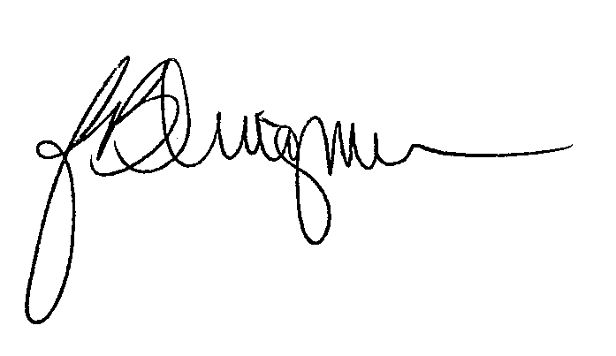
Sincerely,

Jake Dingman
Old Mill Days

The Oakesdale Historical Society thanks the following 2015 Old Mill Days financial sponsors:

Crossett’s Food Market
Carmen Bruya & Team Washington Real Estate
Tim Bruya & Bank of Fairfield
Busch Distributors
Jerry Binder, D.M.D.
B-N-P Lentil Company
Whitman Medical Group
The Courtyard at Colfax
St. John Hardware & Implement
Libey & Ensley, PLLC
Dave’s Auto Body & Glass, Inc.
Pickard Orthodontics
Wilbur-Ellis
The Fit Farm
Folsom Ace Hardware
Tom Kammerzell
Medical Micro Machining
Rosauers
Jones Truck and Implement
Bruce Mills

